**Automobile Service and Product Management System**

**Project Proposal**

**CS 45**

Details of the Supervisor

Name: Dr. (Ms) K.H.E.L.W Hettiarachchi

Signature: ……………………………….

Date:

Details of the Co -supervisor

Name: Mrs. Hirasha Pooliyadda

Signature: ……………………………….

Date:

Team members

|  |  |  |
| --- | --- | --- |
| Number | Full Name | Index Number |
| 1 | N. S. Elvitigala | 20000482 |
| 2 | B. A. Sathyanjana | 20001681 |
| 3 | E. S. D. Senewirathne | 20001738 |
| 4 | T. H. T. C. Gunathilaka | 20000652 |

**Table of content**

**1.** **Introduction** 8

**1.1** **Problem statements and existing environment** 8

**1.2** **Solution** 9

**2.** **Project scope** 10

**2.1** **Project identification and boundaries** 10

**2.2** **In-scope** 10

**2.3** **Out-scope** 12

**2.4** **Constraints and assumption** 12

**3.** **Project goal and objectives** 14

**3.1** **Project goal:** 14

**3.2** **Objective of the project:** 14

**4** **Project feasibility** 15

**4.1** **Social feasibility** 15

**4.2** **Technical feasibility** 19

**4.3** **Economic feasibility** 20

**4.4** **Legal and ethical feasibility** 21

**4.5** **Operational feasibility** 22

**5** **Deliverables of the project** 23

**6** **Requirements** 24

**6.1** **Functional requirements** 24

6.1.1 Use case diagram 26

6.1.2 Use case narratives 27

6.1.3 Activity diagrams 58

6.1.4 Component diagram 101

**6.2** **Quality attributes** 102

6.2.1 Availability 102

6.2.2 Modifiability 102

6.2.3 Security 102

6.2.4 Performance 103

6.2.5 Testability 103

6.2.6 Usability 104

**7** **Technologies to be used** 105

7.1 Front – end development 105

7.2 Back – end development 105

7.3 Database 105

7.4 IDE 106

7.5 Development server 106

7.6 Version control and collaboration 106

7.7 Project management tool 107

7.8 Diagram drawing tool 107

7.9 Storage for document 107

7.10 Team meetings 107

**8** **Project timeline** 108

**9** **Declaration** 109

References 110

**List of Tables**

Table 1: Log in User 27

Table 2: Forget Password – User 28

Table 3:Log Out – User 28

Table 4: Create Account – Customer 29

Table 5: View Products - Customer 30

Table 6: View Services – Customer 31

Table 7: Manage Account Details – Logged in Customer 32

Table 8: Reset Password – Logged in Customer 33

Table 9:Checkout Products - Logged in Customer 34

Table 10: View Past Orders - Logged in Customer 34

Table 11: View Pending Orders - Logged in Customer 35

Table 12: Post Reviews - Logged in Customer 36

Table 13: Add Cart - Logged in Customer 36

Table 14: View Cart - Logged in Customer 37

Table 15: Manage the Cart - Logged in Customer 37

Table 16: Make Online Payment - Logged in Customer 38

Table 17: View Payment History Logged in Customer 38

Table 18: View Appointment – Logged in Customer 39

Table 19: Manage Appointments - Logged in Customer 39

Table 20: View Vehicle - Logged in Customer 40

Table 21: View Vehicle History - Logged in Customer 40

Table 22: View the Progress - Logged in Customer, Technician 41

Table 23: View Inventory - Stock Manager 41

Table 24: Add New Products - Stock Manager 42

Table 25: Restock Products - Stock Manager 42

Table 26: Remove Products - Stock Manager 43

Table 27: Update Products - Stock Manager 43

Table 28: View Orders - Stock Manager 44

Table 29: Analyze Sales - Stock Manager 44

Table 30: View Product Reviews - Stock Manager, Logged in Customer 45

Table 31: Add Supplier - Stock Manager 45

Table 32: Delete Supplier - Stock Manager 46

Table 33: Update Supplier - Stock Manager 46

Table 34: View Suppliers - Stock Manager 47

Table 35: Issue Products Inhouse - Stock Manager, Technician 47

Table 36: Generate Fault Report - Foreman 48

Table 37: Generate Cost Estimation Report - Foreman 49

Table 38: Check Vehicle - Foreman 50

Table 39: Check Inventory - Foreman, Office Staff 51

Table 40: Manage the Job Board - Foreman 51

Table 41: View Jobs - Foreman 52

Table 42: Assign Technician - Foreman, Technician 52

Table 43: Update Service Progress - Technician 53

Table 44: Check Admitting Report - Security Officer 53

Table 45:Checkout Appointment Details - Security Officer, Logged in Customer 54

Table 46: Generate Admitting Report - Security Officer, Logged in Customer 54

Table 47: Open Job Card – Office Staff Member 55

Table 48: Create Account - Office Staff Member 55

Table 49: Make Appointments by Call - Office Staff Member, Logged in Customer 56

Table 50: Generate Invoice - Office Staff Member 56

Table 51: View Customer Detail - Office Staff Member, Logged in Customer 57

**List of Figures**

Figure 1: Survey results 1 15

Figure 2: Survey Result 2 16

Figure 3: Survey Result 3 16

Figure 4: Survey Result 4 17

Figure 5: Survey Result 5 17

Figure 6: Survey Result 6 18

Figure 7: Survey Result 7 18

Figure 8: Survey Result 8 19

Figure 9: Use Case Diagram 26

Figure 10: Log In - User 58

Figure 11: Log Out - User 59

Figure 12: Create Account - User 60

Figure 13: Search and Filter Products - Customer 61

Figure 14: Search and Filter Services - Customer 62

Figure 15: Manage Account Details – Logged in Customer 63

Figure 16: Checkout Products - Logged in Customer 64

Figure 17: Forget Password – Logged in Customer 65

Figure 18: View Past Orders - Logged in Customer 66

Figure 19: View Pending Orders - Logged in Customer 67

Figure 20: Add to Cart - Logged in Customer 68

Figure 21: View Cart - Logged in Customer 69

Figure 22: Manage the Cart - Logged in Customer 70

Figure 23: Make Online Appointment - Logged in Customer 71

Figure 24: View Payment History - Logged in Customer 72

Figure 25: View Appointment History - Logged in Customer 73

Figure 26: Manage Appointments - Logged in Customer 74

Figure 27: View Vehicle - Logged in Customer 75

Figure 28: View the Progress - Logged in Customer 76

Figure 29: Add Supplier - Stock Manager 77

Figure 30: Delete Supplier - Stock Manager 78

Figure 31: View Product Reviews – Stock Manager 79

Figure 32: View Orders - Stock Manager 80

Figure 33: Update Supplier - Stock Manager 81

Figure 34: Add New Products - Stock Manager 82

Figure 35: Restock Products - Stock Manager 83

Figure 36: Remove Products - Stock Manager 84

Figure 37: Generate Fault Report - Foreman 85

Figure 38: Check Vehicle History - Foreman 86

Figure 39: View Jobs - Foreman 87

Figure 40: Manage Job Board – Foreman 88

Figure 41: Assign Technician - Foreman 89

Figure 42: Update Service Progress – Technician, Foreman 90

Figure 43: Check Admitting Report - Security Officer 91

Figure 44: Check Appointment Details – Logged in Customer, Security Officer 92

Figure 45: Open Job Card - Logged in Customer, Office Staff Member 93

Figure 46: Create Customer Account - Office Staff Member 94

Figure 47: Make Appointment by Call – Logged in Customer, Office Staff Member 95

Figure 48: Generate Invoice - Logged in Customer, Office Staff Member 96

Figure 49: View Customer Details - Office Staff Member 97

Figure 51: Create employee account - Admin 98

Figure 52: Manage employee accounts - Admin 99

Figure 53: View analytics - Admin 100

Figure 53: Component Diagram 101

Figure 54: Front-End Development 105

Figure 55: Back-End Development 105

Figure 56: Database 106

Figure 57: IDE I 106

Figure 58: IDE II 106

Figure 59: Development Server 106

Figure 60: Version Control and Collaboration 107

Figure 61: Project Management Tool 107

Figure 62:Diagram Drawing Tool 107

Figure 63:Storage Document 107

Figure 64: Team Meetings 107

Figure 65: Project Timeline 108

Figure 66: Declaration Table 109

# **Introduction**

Vehicles are one of the most prized possessions of any person. Because of this, people often get disappointed when the maintenance experience of their vehicles is terrible. Mismanagement of employees and poor customer service from service centers is not helping with it either. This problem exists everywhere, and surveys done throughout the world suggest that most vehicle owners are dissatisfied with the service gets from Service centers [1] [2].

This is partly due to the simplified systems most service stations use. Those systems provide ways to manage stocks, invoices, and vehicles but not for managing the servicing process of vehicles. Manual process used at most places is troublesome for both the company and the customers. Service centers can't track their employees' efficiency easily and this may lead to loss of valuable man hours.

Proposed project aims to help both customers and the company by providing a system where all the service/repairs and products are managed properly, and customer service is high.

## **Problem statements and existing environment**

After discussing with some owners of selected service centers, garages, auto-part shops, and vehicle owners and studying systems currently in use, some issues were observed.

* Some garages/service centers do not maintain customer details or vehicle details on behalf of their side, and only the vehicle owners have the details of previous services. This leads to miscommunication about issues in the vehicle between customers and technicians.
* Service centers that maintain customer details are storing data in hard copies. This is less scalable and it's hard to lookup data when needed. Also, the longevity is heavily compromised.
* All the forms and reports are filled in papers. Furthermore, office staff should have to manually enter details into the system if they are using one. Otherwise, records will be stored in Files.
* Customers have to wait in queues if the service station is busy
* Foremen and technicians might miss a few jobs/tasks due to manual system.
* Auto-part shops need to analyze sales manually.
* If the customer wants to find out auto-parts availability and details, they have to make calls and ask for the details,
* Customers cannot order products online.
* When there is a repairing, customers always have to make calls to know the progress of the job
* Companies with service centers which also sell auto-parts do not have one system to manage services, products, and online orders; those separate systems are not syncing. Because of this stock availability is unknown precisely and some website advice customers to call and check stock before ordering because of this issue.

## **Solution**

To solve the above-identified problems, the proposal is to make an Automobile service center and Auto-part management system, which can manage customer appointments, service and repair workflows, and product orders in one system.

The system has features to find service records, generate reports, and handle repairs and services by providing required features in the multiple stages of repairs and services. (Example: for a typical full service, the system should implement features to handle vehicle admitting, generate fault reports, manage jobs, assign technicians, and generate the quotation/invoices).

Also, the system should have features to manage the stock of spare parts, electronic parts, batteries, engine oil, etc., and sell these auto parts online. There will be a website where people can search for specific products, maintain a cart, and order them. These purchases should reflect on the system by correctly managing stock. This website also should double as the marketing website for the company.

This website will also allow online appointments for services and repairs by selecting a preferred slot. Vehicle owners can see their service history, appointment details, and vehicle details. When a vehicle owner is faced with a repair that takes some time, he/she can track the job's progress. Also, they can add reminders for services using this website.

# **Project scope**

## **Project identification and boundaries**

The project's goal is to create a system for managing products and services for a automobile services center.

Proposed system has 7 user roles. Those are,

* 1. Customer (both authenticated and not)
  2. Stock Manager
  3. Security Officer
  4. Office Staff Member
  5. Foreman
  6. Technician
  7. Admin
* The system's purpose is to ease operations of the vehicle service center and provide customers a better experience. Also, the inner process of the service center will be digitized using this system. Customers will be able to order products online, make appointments online, and manage service/repair of their vehicles. From the company’s perspective, they will be able to manage the service/repair process, stock management and employee management. This system hopes to increase the efficiency of the service station and user satisfaction.

## **In-scope**

Below are the features a customer (vehicle owner) can expect from the system.

* Any customer can visit the website and discover what are the service and products offered by the company.
* Customers with accounts will be able to add products to a cart and checkout them to deliver to their location.
* Customers with accounts will be able to select service types and make an appointment online by seeing available timeslots.
* Registered customers will be able to see pending orders, ongoing service progress, past service history etc.
* Get and view notifications about up-coming periodic services.

Stock manager role can expect these features.

* Add suppliers, update details of suppliers and remove suppliers from the system.
* Manage spare parts/accessory inventory.
* Handle online orders.
* Distribute products for in-house services/repairs.

Foreman role can expect these features.

* Generate fault reports.
* Assign technicians to tasks and update service job cards.
* Oversee the progress of vehicle repairs & services.

Security officer role can expect these features.

* Validate appointment dates before admitting vehicles.
* Generate admitting reports and check them before leaving.

Technician role can expect these features.

* Get notified when they're assigned to a job.
* Mark tasks as completed in the job card.
* View previous jobs they were assigned to.

Office Staff Member role can expect these features.

* Open job cards for customers, create accounts for them and create new vehicle entries in the system
* Invoicing and issuing quotations for customers.
* Make appointments on behalf of customers.

Admin role can expect these features.

* Manage employee accounts (add new employees, update details and remove accounts)
* View analytics and generate reports based on all aspects of the system

This System will use notification features in some cases like,

* when notifying assignment to a job to a technician.
* Notify customer after job finishes
* Notify foremen when all tasks are done by the technicians
* Send scheduled service reminders to customers.

Also, payment handling will be implemented for the online ordering of spare parts and accessories.

## **Out-scope**

Although the proposed system takes care of many things in the service station, some aspects are out of the scope of this project.

* Cash register and physical payment handling
* Since this is a web-based system and it’s not straightforward to connect cash registers (physical payments) for the office staff members when accepting payments from customers, this system doesn’t handle that. Instead, office staff members will have to manually mark invoices as paid. However, payment processing for online payments when ordering through the website is supported by the system.
* Employee salary management & attendance tracking
* The proposed system doesn’t handle the aspect of employee salary management and it doesn’t provide features to track the attendance of employees
* Delivery progress management,
* Although the system notifies customers when orders are processed and sent to deliver, the proposed system doesn’t include features to track its location and status
* Direct integration with printers
* Printing invoices/quotations and other reports are only done through the web browser interface for printing, this system doesn’t directly connect with any specific printers.

## **Constraints and assumption**

Two categories of project-related restrictions and assumptions have been identified. There are some restrictions regarding the project and there are some assumptions and constraints to consider regarding the proposed system.

As per development constraints and assumptions,

* No frameworks are allowed. Project must use the fundamental technologies to build the system from scratch.
* The project should be completed in one academic year.
* It’s assumed that the workload is fairly divided among all team members to make sure everyone benefits from the project.

As per constraints and assumptions regarding the system,

* All the users must have an internet connection to connect to the system as this is a web-based system.
* Customers cannot cancel orders after the products are on the way.
* Assumed that users possess simple it and language skills to operate this system
* Assumed that all the employees have devices that are capable of using this web application.

# **Project goal and objectives**

## **Project goal:**

This project aims to develop a fully functional, user-friendly Automobile services and product management system. It hopes to minimize the problems that service center employees face when doing service/repair jobs and maximize their efficiency and satisfaction to provide high-quality work. Also, the project will provide vehicle owners with a user friendly and simple way to take care of their vehicles by easing the service and repairing processes and facilitating easier online purchases. By improving both the customer satisfaction and employee satisfaction and streamlining the management, it hopes to help the company in achieving its financial growth goals.

## **Objective of the project:**

* Design a service management system to reduce customers waiting time and facilitate foremen and technicians to manage their tasks more efficiently to increase productivity.
* Design the system to reduce paperwork and save employees time by keeping the system up to date.
* Help foremen and office staff generate reports, quotations, and invoices.
* Help vehicle owners to track the progress of jobs and assist them in getting reminders

whenever they need them.

* Design an inventory management system to manage products, keep the information up to date and facilitate managers to analyze sales and order the products, which can increase profits.
* Help company managers generate reports and do analytics to grow the business.
* Provide a platform for the company to sell its products and services.
* Solve all the problems mentioned above in the existing environment to our knowledge.

# **Project feasibility**

By looking at existing solutions and conversing with People who work in this field, it's possible to gain a clear look at the feasibility of the proposed system in technical, economic, legal, ethical, operational, and scheduling aspects.

## **Social feasibility**

To gain insights into people’s opinion on a system like this where they can easily order spare parts/accessories and service/repairing of their vehicles straightforwardly, we conducted a survey and got 141 responses. Given below is each question we asked and the response to it.

Question number 1:

Figure 1: Survey results 1

Question number 2:

Figure 2: Survey Result 2

Question number 3:

Figure 3: Survey Result 3

Question number 4:

Figure 4: Survey Result 4

Question number 5:

Figure 5: Survey Result 5

Question number 6:

Figure 6: Survey Result 6

Question number 7:

Figure 7: Survey Result 7

Question number 8:

Figure 8: Survey Result 8

Responses to this survey and the general dissatisfaction about vehicle servicing process proves that a system like this suits and is socially feasible.

## **Technical feasibility**

The system will consist of several web-based user interfaces, all connected to a central backend. Those are the online-store website and dashboards for employees of the company.

* Front End technologies that are going to be uses for the development consist of HTML, CSS, and JavaScript. These technologies are used because for frontend web application, these technologies are a must as web browsers only support these technologies. However, managing CSS in a large project is difficult to mitigate this problem, the project will be developed with Sass syntax, which is just a way to write CSS more like a programming language. All these technologies are free to use.
* PHP and MySQL will be used as server-side programming language and the database respectively. PHP programming language is used because features it provides to easily write production ready backends even without the help of any frameworks. It's also very popular and has a huge community around so it's easy to get answers to problems. Both these technologies are free to use.
* VSCode and PhpStorm will be used IDEs. Visual Studio Code is used because it's light weight but still provides a great number of features when it comes to frontend development. PHPStorm will mainly be used as the IDE for PHP as it provided outstanding features including best-in-class SQL support. VSCode is freely available and PhpStorm licensed are provided with the university email.
* The web applications will be hosted in a shared hosting service in the beginning since it's only targeting limited and mostly consistent amount of user base that could be slowly developing (Only new customers will increase user base and it won't cause any problems with the shared hosting plan). The service center will be able manage the cost of shared hosting and the domain.

Therefore, it is evident implementing this system is technically feasible because cost of tools are completely free and the knowledge to use them are easily attainable.

## **Economic feasibility**

Tools used for the development of the system are mostly free, only MS Office and PHPStorm aren’t free but all the team members have licenses for those two.

* All the technology used for the actual implementation is free except for google maps API, but even that comes with a generous free trial. Since we are developing this system targeting a large-scale automobile servicing company there won’t be issues regarding the google maps API.
* During development, we’ll be using XAMPP, a development environment for PHP projects.
* In production, the web system will require a domain when launched, and it can be purchased by the company for approximately 10$ from any domain registrar.
* for hosting the web application, a shared hosting plan will be sufficient initially and we assume the cost for that is manageable by the company.
* The marketing website (also works as the online store) can be accessed by any device. But we recommend employee accounts be accessed by a PC/Laptop or tab due to the amount of data that will be presented in those UIs. Technicians can use their mobile devices to access the technician web application which is mobile responsive. It's assumed that PCs are already available for Admin, Office Staff members and Stock manager. Foremen will have to use a Tab or mobile device to access their application since they aren’t usually in an office.
* while this system requires a payment getaway, it’ll be using a sandbox account to simulate payments for now, so there won't be any costs.
* Team collaboration will be done through mainly GitHub and Trello and occasional online meetings done via Zoom/MS Teams. Data charges to access these services are manageable for the team.

Considering all the above, it's clear that the project is economically feasible.

## **Legal and ethical feasibility**

As the customers can order products online, to ensure safety of customer's payments the system won't save credit card details in the system in plain text and handle payments via a reputed payment getaway. To make sure their payment records are easily accessible, customers will be able to easily access them in their profile and will receive email receipts whenever they make a payment whether it's an online or physical payment.

In every communication done in the system, data will be sent with SSL encryption to make sure data is not readable even if it's intercepted by a 3rd party.

The system will store large amounts of sensitive user data and there’s a responsibility to protect them and inform them about how the system uses that data. To ensure the safety of user accounts even in a data breach, the system doesn't store sensitive data like password in plain text and use a hashing method that provides optimal security. Also, as customers should be aware of how the system is using data, user agreement will provide necessary details and make sure customers understand before creating accounts. Also, they will be prompted about the cookies that will be stored in their browsers. And a detailed privacy policy will include that the system doesn't share user information with any 3rd parties.

In a more ethical concern, at the start of a servicing of a vehicle, security officer record external condition of a vehicle before admitting to the service center, thus customers have proof if there was some damage done by the technicians and this also prevents false accusations from vehicle owners.

Majority of the technology used by the project is open source and has permissive licenses that allow unlimited personal and commercial use. Project will also use google maps API, which is closed source, but there won't be any issues regarding usage because it's a paid product. Thus, there are no issues regarding licensing of software and using for a commercial application.

Therefore, considering all these, the system is legally and ethically feasible.

## **Operational feasibility**

The proposed system aims to provide a streamlined way for the automobile service company to handle its process while providing their clients a way to reliably consume their services.

In the existing manual process of servicing, massive amounts of man hour are wasted due to mismanagement of technicians. Through this system, foremen can assign technicians to a job and monitor the progress easily. This can easily increase profits of the company by doing more service/repair jobs in the same period compared to previous methods.

The system is planned to be user-friendly and straightforward as possible to make sure it’s easy to use by both the employees of the company and vehicle owners. It will include easy navigation to improve usability.

Job process management can be done straightforwardly by creating a task list and assigning technicians, and technicians can mark the progress by each task. Vehicles owners can easily see the progress of a job because of this. This answers a problem in previous methods where customers were left in the blind about progresses unless they call and ask.

A dark mode will be implemented to ensure accessibility to users who are uncomfortable with viewing bright displays. And it will support all kinds of devices so no users are left out. It's assumed that all users have fundamental technical skills to use the system.

As such, it's clear that the proposed system solves many issues of previous methods and is easily usable by user roles. It also makes the service center efficient. Considering all these, it's clear that the proposed project is operationally feasible.

# **Deliverables of the project**

At the end of the project, the following will be delivered.

1. Separate web applications for user groups.
2. User manuals with screenshots
3. License agreements for customers.
4. Installation guide, how do you set this up on a server and how to setup domains.
5. Software requirement specification.

# **Requirements**

## **Functional requirements**

The user roles identified were,

1. Customer
2. Stock Manager
3. Admin
4. Technician
5. Security Officer
6. Office Staff
7. Foreman

**Customer**

* There are two types of customers in the system. Unregistered customers can only search the products and services rather than buy the products and making an appointment. They also can create an account and promoted as a logged in customer.
* Newly customers can be promoted as a logged in customers after providing required details and confirming email address.
* Registered customers can manage account details such as reset passwords using their emails.
* Registered customers can add products to the cart, view cart and manage cart. They also buy the products through the system by making payment.
* View past orders, pending orders, and post review features are available only for logged in customers.
* They can make an appointment and check the appointment details through the system. They also get an email after confirming the appointment.
* There is a feature for logged in customer to view the progress of long-term repair. Also, they can view the past service history and payment history after logged in to the account.

**Stock Manager**

* Stock manager should log in to the system before using any of the service.
* Stock managers need to manage the inventory. Add new products, restock, delete, update, and view products are the main features available for the stock manager.
* Check ordered products, view product reviews, and analyze sales are also mange by the stack manager.
* View, add, update, and delete suppliers are also manage by the stock manager.
* Inhouse distribution is managed by the stack manager with the technician after checking the inventory.

**Admin**

* Admin accounts are created by the system designers. If there is any inquire, admin need to contact the system designer.
* Creating and managing employee accounts are handle by the admin. Admin can delete, update, and change the passwords of the employee accounts.
* Admin can generate analytics reports.

**Technician**

* Technicians should be logged in to the system before update the service/repair progress.
* Technicians can request spare parts through the system when they need it.

**Security Officer**

* Security officer should be logged in to the system before checking the appointment details.
* When there is an appointment, security officer checks the details and give access to the premises.
* Security officers need to generate an admitting report for every vehicle at the beginning of the service/repair and check that report at the end of the service/repair for ensure there is no difference between those reports and note it to the system.

**Officer Staff**

* Office staff should log in to the system before view customer details such as service history, payment history.
* When there is a customer without an appointment, office staff should create an account and making an appointment on behalf of the customer. Also do the same for the customers who are interact in the phone calls.
* Generate invoice is the feature of office staff.

**Foreman**

* Foreman should log in to the system before generating the fault report, check availability of parts, and generate cost estimation report.
* Foreman can also generate a quotation for the customer.
* Foreman can check the vehicle history after inserting vehicle details and check the inventory as well.
* Foreman can assign technicians after checking their availability and manage job boards.

### Use case diagram

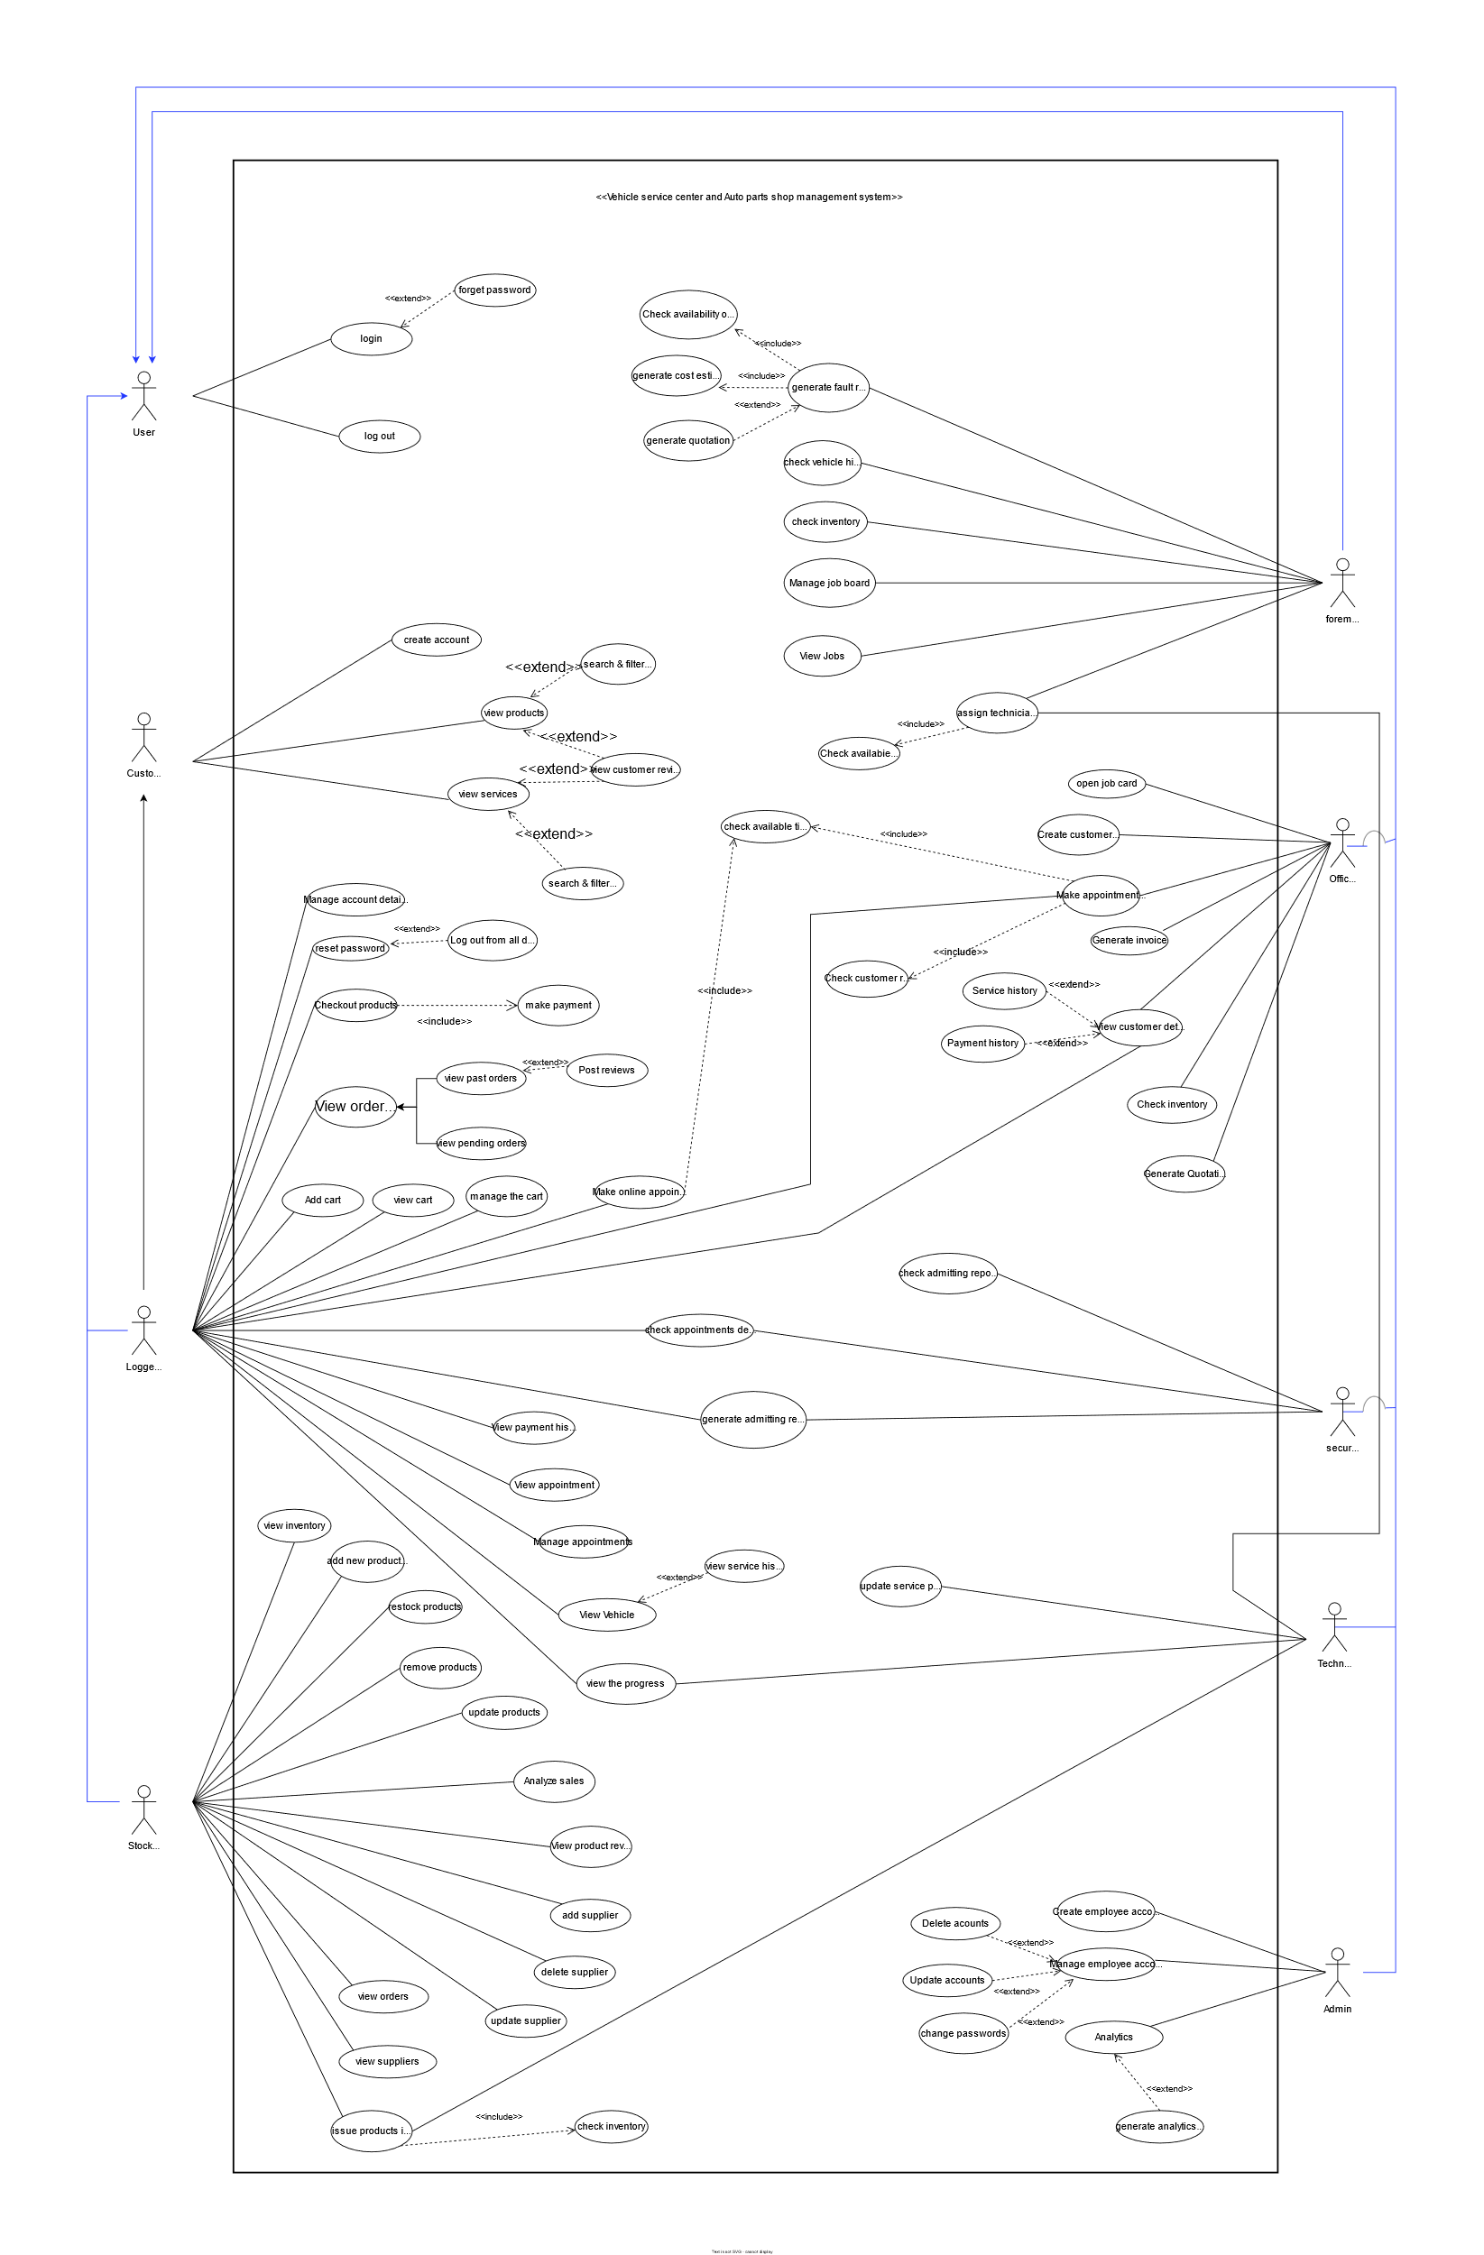

Figure 9: Use Case Diagram

For better view:

<https://drive.google.com/file/d/1sKe3-_ozSORir34p5FgLTtx1u2gwCZBB/view?usp=sharing>

### Use case narratives

1. Log in

|  |  |  |
| --- | --- | --- |
| **Use Case** | Log in | **Summary**  Users can log into their respective dashboard |
| **Use Case Id** | 01 |
| **Actors** | User | |
| **Preconditions** | Must be registered in the system | |
| **Descriptions** | All the actors mentioned here can log in to their respective dashboards using their credentials | |
| **Exceptions** | An account with the given email does not exist, entered password does not match with the account | |
| **Postconditions** | If login is successful, redirect to dashboard | |

Table 1: Log in User

1. Forget password

|  |  |  |
| --- | --- | --- |
| **Use case** | Forget password | **Summary**  If forget the password, then reset the password |
| **Use case ID** | 02 |
| **Actors** | Logged in customer | |
| **Preconditions** | Must have an account | |
| **Descriptions** | When trying to log into the system, if customers forgot their password, they could enter the email they used to create the account to get an OTP where they can reset the password | |
| **Exceptions** | Account with the entered email does exist. | |
| **Postconditions** | If successful, the password will be reset. | |

Table 2: Forget Password – User

1. Log out

|  |  |  |
| --- | --- | --- |
| **Use case** | Log out | **Summary**  User can log out from the system. |
| **Use case ID** | 03 |
| **Actor** | User | |
| **Preconditions** | user should be logged into the system | |
| **Descriptions** | The user can log out from the system whenever they need | |
| **Exceptions** | None | |
| **Postconditions** | user will have to sign in again to use the system | |

Table 3:Log Out – User

1. Create account

|  |  |  |
| --- | --- | --- |
| **Use case** | Create account | **Summary**  Customers can create an account or office staff can create an account for them |
| **Use case ID** | 04 |
| **Actors** | Customer | |
| **Preconditions** | An account with this email cannot exist. | |
| **Descriptions** | Customer can create a new account using a new mail with the correct password and get details (name, address, contact number). After entering the email, will receive a verification email to verify the email. | |
| **Exceptions** | An account with this email already exists, the password is not related to the format | |
| **Postconditions** | If successful, the account will be created in the system and the customer will gain access to the profile page. | |

Table 4: Create Account – Customer

1. View products

|  |  |  |
| --- | --- | --- |
| **Use case** | View products | **Summary**  customers can view products |
| **Use case ID** | 05 |
| **Actors** | Customer | |
| **Preconditions** | - | |
| **Descriptions** | Customers can view products that are being displayed by the company on the website. When searching for products, customers can filter products as well. After clicking on a product, the customer will be redirected to a page with all the details of the product. Customers can also review the products on the product detail page | |
| **Exceptions** | None | |
| **Postconditions** | None | |

Table 5: View Products - Customer

1. View services

|  |  |  |
| --- | --- | --- |
| **Use case** | View services | **Summary**  Customers can view services. |
| **Use case ID** | 06 |
| **Actor** | Customer | |
| **Preconditions** | None | |
| **Descriptions** | Customers can view services that are being displayed by the company on the website. When searching for services, customers can filter services as well. After clicking on a service, the customer will be redirected to a page with all the details of the service and a “Create an Appointment” button will be displayed if the customer is currently logged in | |
| **Exceptions** | None | |
| **Postconditions** | None | |

Table 6: View Services – Customer

1. Manage account details

|  |  |  |
| --- | --- | --- |
| **Use case** | Manage account details | **Summary**  Customers can manage their account details. |
| **Use case ID** | 07 |
| **Actor** | Logged in customer | |
| **Preconditions** | Customer logged into the system | |
| **Descriptions** | Customers can manage their account details. Apart from viewing account details, they can also change account details | |
| **Exceptions** | None | |
| **Postconditions** | Changes to the updated profile info will be reflected in the system | |
| **Assumptions** | Vehicle details can only be changed by office staff. | |

Table 7: Manage Account Details – Logged in Customer

1. Reset password

|  |  |  |
| --- | --- | --- |
| **Use case** | Reset password | **Summary**  Customers can reset their passwords. |
| **Use case ID** | 08 |
| **Actor** | Logged in customer | |
| **Preconditions** | Customer logged into the system | |
| **Descriptions** | Customers can reset their password. For that, they must re-enter the current password and give a new password and enter the new password again to confirm. After resetting the password, the customer can decide on whether to stay logged in or log out from all devices | |
| **Exceptions** | Current password did not match | |
| **Postconditions** | * Display successful reset password. * If a customer chooses to log out from devices, the customer has to sign in again. | |

Table 8: Reset Password – Logged in Customer

1. Checkout products

|  |  |  |
| --- | --- | --- |
| **Use case** | Checkout products | **Summary**  Customer can checkout products |
| **Use case ID** | 09 |
| **Actor** | Logged in customer | |
| **Preconditions** | Customer logged into the system. | |
| **Descriptions** | Customers can check out products (either item that is in the cart or not), they need to choose a payment method (cash on delivery or credit/card) and enter delivery addresses. If they choose credit/debit cards, payment will be handled by the system. | |
| **Exceptions** | * stock unavailable * credit/debit verification failed | |
| **Postconditions** | order will be displayed as a pending order  product quality should change accordingly | |

Table 9:Checkout Products - Logged in Customer

1. View past orders

|  |  |  |
| --- | --- | --- |
| **Use case** | View past orders | **Summary**  Customer can view past orders. |
| **Use case ID** | 10 |
| **Actor** | Logged in customer | |
| **Preconditions** | Customer logged into the system. | |
| **Descriptions** | Customers can view the products they have purchased using the system and they can post reviews on that product if they want. | |
| **Exceptions** | None | |
| **Postconditions** | None | |

Table 10: View Past Orders - Logged in Customer

1. View pending orders

|  |  |  |
| --- | --- | --- |
| **Use case** | View pending orders | **Summary**  Customers can view pending orders. |
| **Use case ID** | 11 |
| **Actor** | Logged in customer | |
| **Preconditions** | Customer logged into the system | |
| **Descriptions** | After ordering something, customers can view the pending orders to view details such as,   * product name * cost * status of the order (Is it shipped or not?) | |
| **Exceptions** | None | |
| **Postconditions** | None | |

Table 11: View Pending Orders - Logged in Customer

1. Post reviews

|  |  |  |
| --- | --- | --- |
| **Use case** | Post reviews | **Summary**  Customer can add reviews for the products they’ve purchased |
| **Use case ID** | 12 |
| **Actor** | Logged in customer | |
| **Preconditions** | * Customer logged into the system * Customer must have purchased the item | |
| **Descriptions** | Customers can post reviews for the products they have purchased using the system. reviews can contain text and images. also, they can rate the product using stars.  Other customers can decide on ordering these items based on this | |
| **Exceptions** | None | |
| **Postconditions** | None | |

Table 12: Post Reviews - Logged in Customer

1. Add cart

|  |  |  |
| --- | --- | --- |
| **Use case** | Add cart | **Summary**  Customer can add the products to the cart |
| **Use case ID** | 13 |
| **Actor** | Logged in customer | |
| **Preconditions** | Customer logged into the system | |
| **Descriptions** | After choosing the product, customer can add products to the cart. | |
| **Exceptions** | None | |
| **Postconditions** | None | |

Table 13: Add Cart - Logged in Customer

1. View cart

|  |  |  |
| --- | --- | --- |
| **Use case** | View cart | **Summary**  Customer can view the cart |
| **Use case ID** | 14 |
| **Actor** | Logged in customer | |
| **Preconditions** | Customer logged into the system | |
| **Descriptions** | The customer can view the cart. | |
| **Exceptions** | None | |
| **Postconditions** | None | |

Table 14: View Cart - Logged in Customer

1. Manage the cart

|  |  |  |
| --- | --- | --- |
| **Use case** | Manage the cart | **Summary**  Customer can manage the cart |
| **Use case ID** | 15 |
| **Actor** | Logged in customer | |
| **Preconditions** | Customer logged into the system | |
| **Descriptions** | The customer can increase the amount of an item in the cart and delete items from the cart. | |
| **Exceptions** | None | |
| **Postconditions** | None | |

Table 15: Manage the Cart - Logged in Customer

1. Make online payment

|  |  |  |
| --- | --- | --- |
| **Use case** | Make online appointment | **Summary**  Customers can make an appointment for services. |
| **Use case ID** | 16 |
| **Actor** | Logged in customer | |
| **Preconditions** | Customer logged into the system | |
| **Descriptions** | Customers can check availability of time slots by day and create an appointment in a vacant time slot. customers should enter details regarding the appointments and will receive a QR code via email. they can also see the QR code when checking appointment details | |
| **Exceptions** | None | |
| **Postconditions** | Time slot will be allocated and QR code will be generated for the customer | |

Table 16: Make Online Payment - Logged in Customer

1. View payment history

|  |  |  |
| --- | --- | --- |
| **Use case** | View payment history | **Summary**  Customer can view payment history |
| **Use case ID** | 17 |
| **Actor** | Logged in customer | |
| **Preconditions** | Customer logged into the system | |
| **Descriptions** | Customers can view payment history of their past orders and services/repairs. | |
| **Exceptions** | None | |
| **Postconditions** | None | |

Table 17: View Payment History Logged in Customer

1. View appointment

|  |  |  |
| --- | --- | --- |
| **Use case** | View appointments | **Summary**  Customers can view their upcoming appointments |
| **Use case ID** | 18 |
| **Actor** | Logged in customer | |
| **Preconditions** | Customer logged into the system | |
| **Descriptions** | Customers can view details such as date and time of upcoming appointments. | |
| **Exceptions** | None | |
| **Postconditions** | None | |

Table 18: View Appointment – Logged in Customer

1. Manage appointments

|  |  |  |
| --- | --- | --- |
| **Use case** | Manage appointments | **Summary**  Customers can manage their upcoming appointments |
| **Use case ID** | 19 |
| **Actor** | Logged in customer | |
| **Preconditions** | Customer logged into the system | |
| **Descriptions** | Customers can update and cancel upcoming appointments. When updating an appointment, the customer will have to follow the steps of choosing a time slot and date | |
| **Exceptions** | None | |
| **Postconditions** | The availability of timeslots should change accordingly. | |

Table 19: Manage Appointments - Logged in Customer

1. View vehicle

|  |  |  |
| --- | --- | --- |
| **Use case** | View Vehicle | **Summary**  Customers can view details of their vehicles |
| **Use case ID** | 20 |
| **Actor** | Logged in customer | |
| **Preconditions** | Customer logged into the system | |
| **Descriptions** | Customers can see the information about their vehicles. after clicking on a vehicle, full details of the vehicle are shown in the system, and if wish see the service history that the vehicle | |
| **Exceptions** | None | |
| **Postconditions** | None | |

Table 20: View Vehicle - Logged in Customer

1. View vehicle history

|  |  |  |
| --- | --- | --- |
| **Use case** | View service history | **Summary**  Customer can view service history of their vehicle |
| **Use case ID** | 21 |
| **Actor** | Logged in customer | |
| **Preconditions** | * Customer logged into the system * Chose a vehicle | |
| **Descriptions** | After choosing the vehicle, the customer can see the service history for that vehicle. | |
| **Exceptions** | none | |
| **Postconditions** | None | |

Table 21: View Vehicle History - Logged in Customer

1. View the progress

|  |  |  |
| --- | --- | --- |
| **Use case** | View the progress | **Summary**  Customers can view the progress/status of the vehicle when doing a service/repairing |
| **Use case ID** | 22 |
| **Actor** | Primary: Logged in customer  Secondary: Technician | |
| **Preconditions** | * Customer logged into the system * Vehicle must have a job assigned | |
| **Descriptions** | Customers can see the service/repair progress of the job. when the job is done customer will receive a notification to collect the vehicle | |
| **Exceptions** | None | |
| **Postconditions** | None | |

Table 22: View the Progress - Logged in Customer, Technician

1. View inventory

|  |  |  |
| --- | --- | --- |
| **Use case** | View inventory | **Summary**  View existing products in the inventory |
| **Use case ID** | 23 |
| **Actors** | Stock Manager | |
| **Preconditions** | Log in to stock manager dashboard | |
| **Descriptions** | Stock manager can view existing products, with stock amount of each product, after clicking on a product, it will show all the info of that product | |
| **Exceptions** | In case of no products, a “no products found” message will be displayed | |
| **Postconditions** | none | |

Table 23: View Inventory - Stock Manager

1. Add new product(s)

|  |  |  |
| --- | --- | --- |
| **Use case** | Add new product(s) | **Summary**  Add new product(s) to the inventory |
| **Use case ID** | 24 |
| **Actors** | Stock Manager | |
| **Preconditions** | Log in to stock manager dashboard, supplier of the product must be in the system | |
| **Descriptions** | Stock manager can add new product or several new products to the inventory with initial stock amount, if the supplier doesn’t exist yet, show link to create the supplier as well. | |
| **Exceptions** | All the required info is not filled correctly | |
| **Postconditions** | Office staff will be able to add this product as an expense in invoices, foreman can use the product to create estimates and customers will be able to order the product online. | |

Table 24: Add New Products - Stock Manager

1. Restock products

|  |  |  |
| --- | --- | --- |
| **Use case** | Restock products | **Summary**  Restock existing product(s) in the inventory |
| **Use case ID** | 25 |
| **Actors** | Stock Manager | |
| **Preconditions** | Log into the stock manager dashboard, product must already exist in the system | |
| **Descriptions** | Stock manager can restock products to increase stock amount | |
| **Exceptions** | none | |
| **Postconditions** | If a user couldn’t use this product/these product because it’s out of stock, that issue will be resolved. | |

Table 25: Restock Products - Stock Manager

1. Remove products

|  |  |  |
| --- | --- | --- |
| **Use case** | Remove products | **Summary**  Remove product(s) from inventory |
| **Use case ID** | 26 |
| **Actors** | Stock Manager | |
| **Preconditions** | Log into the stock manager dashboard, product must already exist in the system | |
| **Descriptions** | Stock manager will be able to remove a product or several products from inventory, this also means that product is discontinued. | |
| **Exceptions** | none | |
| **Post Conditions** | Any user won’t be able to use this product. Product listing will be removed from the website | |

Table 26: Remove Products - Stock Manager

1. Update products

|  |  |  |
| --- | --- | --- |
| **Use case** | Update product(s) | **Summary**  Update existing product(s) in the inventory |
| **Use case ID** |  |
| **Actors** | Stock Manager | |
| **Preconditions** | Log in to stock manager dashboard | |
| **Descriptions** | Stock manager can update existing products (change the name, part no, price, etc.). | |
| **Exceptions** | All the required info are not filled correctly | |
| **Post Conditions** | Changes to the product details will be reflected throughout the system. | |

Table 27: Update Products - Stock Manager

1. View orders

|  |  |  |
| --- | --- | --- |
| **Use case** | View orders | **Summary**  View customer online orders |
| **Use case ID** | 28 |
| **Actors** | Stock manager, customer | |
| **Preconditions** | Log in to stock manager dashboard | |
| **Descriptions** | Orders placed through the website by customers can be viewed by the stock manager to prepare them. | |
| **Exceptions** | none | |
| **Postconditions** | Stock manager will start preparing the order | |

Table 28: View Orders - Stock Manager

1. Analyze sales

|  |  |  |
| --- | --- | --- |
| **Use case** | Analyze sales | **Summary**  Analyze sale performance |
| **Use case ID** | 29 |
| **Actors** | Stock Manager | |
| **Preconditions** | Log in to stock manager dashboard | |
| **Descriptions** | Should be able to analyze sale performance through several criteria, also will be able to generate a report (PDF) | |
| **Exceptions** | None | |
| **Postconditions** | None | |

Table 29: Analyze Sales - Stock Manager

1. View product reviews

|  |  |  |
| --- | --- | --- |
| **Use case** | View product reviews | **Summary**  View customer reviews for products |
| **Use case ID** | 30 |
| **Actors** | Stock Manager, logged in customer | |
| **Preconditions** | Log in to stock manager dashboard | |
| **Descriptions** | Should be able to view reviews left by customers for products on the website | |
| **Exceptions** | None | |
| **Postconditions** | None | |

Table 30: View Product Reviews - Stock Manager, Logged in Customer

1. Add supplier

|  |  |  |
| --- | --- | --- |
| **Use case** | Add supplier | **Summary**  Add new suppliers of products to the system |
| **Use case ID** | 31 |
| **Actors** | Stock Manager | |
| **Preconditions** | Log in to stock manager dashboard | |
| **Descriptions** | Stock manager should add a new supplier when the shop buys items from somewhere that’s not yet in the system. All the relevant details should be saved, this feature should also be accessible from adding a new product feature | |
| **Exceptions** | The required details aren’t filled | |
| **Postconditions** | Displays the successfully saved message and stock manager can use this supplier as supplier when adding items to the inventory from now on. | |

Table 31: Add Supplier - Stock Manager

1. Delete supplier

|  |  |  |
| --- | --- | --- |
| **Use case** | Delete supplier | **Summary**  Delete existing supplier from the system |
| **Use case ID** | 32 |
| **Actors** | Stock Manager | |
| **Preconditions** | Log in to the stock manager dashboard | |
| **Descriptions** | Stock manager can delete existing suppliers from the system | |
| **Exceptions** | None | |
| **Postconditions** | Stock manager can no longer use this deleted supplier when restocking or adding a new product to the inventory and when viewing products from this supplier, a flag should be displayed to the stock manager saying that the supplier is discontinued. | |

Table 32: Delete Supplier - Stock Manager

1. Update supplier

|  |  |  |
| --- | --- | --- |
| **Use case** | Update supplier | **Summary**  Update existing supplier details |
| **Use case ID** | 33 |
| **Actors** | Stock Manager | |
| **Preconditions** | Log into stock manager dashboard | |
| **Descriptions** | Stock manager should update details about suppliers if there is any change | |
| **Exceptions** | Required fields aren’t filled in the form | |
| **Postconditions** | Changes will be reflected in all UI’s where supplier details are presented. | |

Table 33: Update Supplier - Stock Manager

1. View supplier

|  |  |  |
| --- | --- | --- |
| **Use case** | View suppliers | **Summary**  View existing suppliers |
| **Use case ID** | 34 |
| **Actors** | Stock Manager | |
| **Preconditions** | Log in to stock manager dashboard | |
| **Descriptions** | Stock manager can view suppliers, this is also containing the links to adding, updating, and deleting suppliers. | |
| **Exceptions** | In case of no suppliers, a “no suppliers found” message will be displayed | |
| **Postconditions** | None | |

Table 34: View Suppliers - Stock Manager

1. Issue products inhouse

|  |  |  |
| --- | --- | --- |
| **Use case** | Issue products inhouse | **Summary**  Issue products for in-house service/repairs |
| **Use case ID** | 35 |
| **Actors** | Stock manager, Technician | |
| **Preconditions** | Log in to stock manager dashboard | |
| **Descriptions** | In most cases, service center technicians need spare parts/accessories to service vehicles. So, stock manager has to issue those needed products to technicians | |
| **Exceptions** | none | |
| **Postconditions** | Correct amount of stock for the issued products will be decreased from the inventory and customers won’t be able to order to online if stocks are 0 after issuing. | |

Table 35: Issue Products Inhouse - Stock Manager, Technician

1. Generate fault reports

|  |  |  |
| --- | --- | --- |
| Use case | Generate fault reports | **Summary**  Foreman creates report about vehicle in inspection |
| **Use case ID** | 36 |
| **Actors** | Foreman |
| **Preconditions** | * Should be logged in as a foreman * Having a job under a customer | |
| **Descriptions** | In the inspection stage, the foreman should create the report using a given template. Report template should include,   * General details about the vehicle. * Status of breaks, suspensions, engine issues and other technical aspects. * Problems customer faced. * Problems foreman noticed. * Parts that need to be replaced.   When including parts, the system should show the parts availability in inventory and cost estimation should also be done according to what services and products are used for the job. He can view the report whenever he needs. | |
| **Exceptions** | None | |
| **Postconditions** | After completing the report, Foreman generates a quotation. | |

Table 36: Generate Fault Report - Foreman

1. Generate cost estimation report

|  |  |  |
| --- | --- | --- |
| **Use case** | Generate cost estimation | **Summary**  Forman can generate cost estimation report |
| **Use case ID** | 37 |
| **Actor** | Foreman | |
| **Preconditions** | * Should be login as a foreman * Should fill the replacing and adding parts in the fault report | |
| **Descriptions** | After filling the parts that are replacing and adding in the service, the costs for the current job is generated by the system and it is shown in the fault report. | |
| **Exceptions** | None | |
| **Postconditions** | Generate a quotation | |

Table 37: Generate Cost Estimation Report - Foreman

1. Check vehicle history

|  |  |  |
| --- | --- | --- |
| **Use case** | Check vehicle history | **Summary**  All the details about previous services and changed parts should be displayed. |
| **Use case ID** | 38 |
| **Actor** | Foreman | |
| **Preconditions** | * Should be login as a foreman * Vehicles need to be registered in the system | |
| **Descriptions** | In the inspection, foreman can look into the previous record of the vehicle to decide what parts should change in the current service / repair.  Check vehicle history should include details such as,   * General details about the vehicle * Previous service dates. * Previous repairing dates. * Parts that changed. * Issues faced. | |
| **Exceptions** | The vehicle is not in the system. | |
| **Postconditions** | None | |

Table 38: Check Vehicle - Foreman

1. Check inventory – Foreman

|  |  |  |
| --- | --- | --- |
| **Use Case** | Check inventory | **Summary**  Check the availability of parts in the inventory, get the details about product |
| **Use Case Id** | 39 |
| **Actors** | Foreman, Office staff | |
| **Preconditions** | Foreman, Office staff have to login to the system. | |
| **Descriptions** | Availability of a product is checked in situations such as,   * Customer order product from office * When Foreman creates fault reports. | |
| **Exceptions** | None | |
| **Postconditions** | None | |

Table 39: Check Inventory - Foreman, Office Staff

1. Manage the job board

|  |  |  |
| --- | --- | --- |
| **Use Case** | Manage the job board | **Summary**  Manage details of the job board |
| **Use Case Id** | 40 |
| **Actors** | Foreman | |
| **Preconditions** | Should be logged in as a foreman. | |
| **Descriptions** | Forman can see the jobs that need to be completed. Also, he can update/edit details of ongoing jobs and assign new technicians to the job if necessary.  When a job is finished, he can end the job and transfer the customer to the office to complete payments | |
| **Exceptions** | None | |
| **Postconditions** | None | |

Table 40: Manage the Job Board - Foreman

1. View jobs

|  |  |  |
| --- | --- | --- |
| **Use Case** | View jobs | **Summary**  Overseeing all ongoing services and repairing jobs. |
| **Use Case Id** | 41 |
| **Actors** | Foreman | |
| **Preconditions** | Should be logged in as a foreman | |
| **Descriptions** | Foremen can oversee and inspect ongoing services and repairs from the job board. Foreman can see individual progress of each job, | |
| **Exceptions** | None | |
| **Postconditions** | None | |

Table 41: View Jobs - Foreman

1. Assign technician

|  |  |  |
| --- | --- | --- |
| **Use Case** | Assign Technicians | **Summary**  Assign technicians for jobs |
| **Use Case Id** | 42 |
| **Actors** | Primary: Foreman  Secondary: Technician | |
| **Preconditions** | * Should be login as a foreman * A job should be created | |
| **Descriptions** | Foreman can assign jobs for technicians by checking their availability and their details and remarks | |
| **Exceptions** | If all technicians are unavailable at the moment, foreman should wait until one get free | |
| **Postconditions** | None | |

Table 42: Assign Technician - Foreman, Technician

1. Update service

|  |  |  |
| --- | --- | --- |
| **Use Case** | Update service progress | **Summary**  Update the progress of ongoing services |
| **Use Case Id** | 43 |
| **Actors** | Technician | |
| **Preconditions** | Should be login as Technician | |
| **Descriptions** | Technicians can update the progress of their jobs according to the report created by the foreman. This will be helpful for tracking the progress when needed. | |
| **Exceptions** | None | |
| **Postconditions** | None | |

Table 43: Update Service Progress - Technician

1. Check admitting report

|  |  |  |
| --- | --- | --- |
| **Use case** | Check admitting report | **Summary**  Compare previously generated admitting report for the vehicle when leaving. |
| **Use case ID** | 44 |
| **Actors** | Security Officer | |
| **Preconditions** | Should be logged as a security officer | |
| **Descriptions** | When a vehicle is leaving, security officer can view the admitting report which is created at the beginning. If there is a mismatch, inquire with the foreman. | |
| **Exceptions** | none | |
| **Postconditions** | If there aren’t any issues, allow the vehicle to leave the premises. | |

Table 44: Check Admitting Report - Security Officer

1. Check appointment details

|  |  |  |
| --- | --- | --- |
| **Use case** | Check appointment details | **Summary**  Check the validity of appointments |
| **Use case ID** | 45 |
| **Actors** | Primary: Security officer  Secondary: logged in customer | |
| **Preconditions** | Should be logged as a security officer | |
| **Descriptions** | If the customer has come for an appointment, scan the QR code sent to the customer to check if appointment details are valid for this date. | |
| **Exceptions** | Time slots and dates are incompatible with the current date. | |
| **Postconditions** | If successful, security officer should direct the customer to open a job. | |

Table 45:Checkout Appointment Details - Security Officer, Logged in Customer

1. Generate admitting report

|  |  |  |
| --- | --- | --- |
| **Use case** | Generate admitting report | **Summary**  When admitting a vehicle to the service center, a security officer creates a report to indicate the status of the vehicle. |
| **Use case ID** | 46 |
| **Actors** | Primary: Security officer  Secondary: logged in customer | |
| **Preconditions** | Should be logged as a security officer | |
| **Descriptions** | When a customer comes for a service or a repair, security officers should inspect the physical status of the vehicle and generate a report. (This report is created to ensure that when customer leaves the service station, any damages are not happened to the vehicle inside the service center) | |
| **Exceptions** | None | |
| **Postconditions** | If there is an appointment, check it. Otherwise, the customer should be directed to the office to open a job. | |

Table 46: Generate Admitting Report - Security Officer, Logged in Customer

1. Open job card

|  |  |  |
| --- | --- | --- |
| **Use case** | Open job card | **Summary**  Creating a job for vehicle services/repairs |
| **Use case ID** | 47 |
| **Actors** | Office staff member | |
| **Preconditions** | * Should be logged as office staff. * The customer and vehicle should be registered in the system | |
| **Descriptions** | Whether the customer has an appointment or not, when a customer comes to the service center for a repair/ service, office staff should open a job card and assign a foreman.  If a customer is not registered in the system, they need to register the customer and vehicle. | |
| **Exceptions** | None | |
| **Postconditions** | Customer will be directed to the assigned foreman | |

Table 47: Open Job Card – Office Staff Member

1. Create customer account

|  |  |  |
| --- | --- | --- |
| **Use case** | Create customer account | **Summary**  Office staff can create accounts for customers who haven’t an account yet. |
| **Use case ID** | 48 |
| **Actors** | Office Staff member | |
| **Preconditions** | Should be logged as a member of office staff. Only can apply for customers who don’t have an account yet. | |
| **Descriptions** | When a customer comes to the service center, office staff will create an account for them if they don't have an account yet. Also, office staff should create a vehicle entry in the system for the customer if needed. | |
| **Exceptions** | * Entered email address is already in use or invalid mail address. * VIN (vehicle identification number) already exists | |
| **Postconditions** | None | |

Table 48: Create Account - Office Staff Member

1. Make appointments by calls

|  |  |  |
| --- | --- | --- |
| **Use case** | Make appointments by calls | **Summary**  Office staff can make appointments for customers through calls |
| **Use case ID** | 49 |
| **Actors** | Primary: Office staff member  Secondary: logged in customer | |
| **Preconditions** | Should be logged as office staff. | |
| **Descriptions** | If a customer requests to make an appointment via call, office staff should be able to fulfill their requests. If a customer doesn't have an account yet, office staff should make it for them. | |
| **Exceptions** | None | |
| **Postconditions** | Customer gets a confirmation mail with a QR code (also appointment details are visible in the customer's profile. | |

Table 49: Make Appointments by Call - Office Staff Member, Logged in Customer

1. Generate invoice

|  |  |  |
| --- | --- | --- |
| **Use case** | Generate Invoice | **Summary**  Issue an invoice after adding costs for all the services and products customers used. |
| **Use case ID** | 50 |
| **Actors** | Office staff member | |
| **Preconditions** | Should be logged as office staff. | |
| **Descriptions** | After either completion of servicing/repairing or just purchases by a customer, office staff generates an invoice including all the products and services consumed by the customer.  This is the final bill. The customer has to pay the amount shown in this invoice (Cash/card). After payment, invoice will be marked as paid and balance will be calculated. | |
| **Exceptions** | None | |
| **Postconditions** | Customer gets both a softcopy via email and a hard copy. | |
| **Assumptions** | Payment processing via cards is out of scope of the system, staff only needs payment confirmation to generate the invoice. | |

Table 50: Generate Invoice - Office Staff Member

1. View customer details

|  |  |  |
| --- | --- | --- |
| **Use case** | View Customer Details | **Summary**  Office staff can view customer service history. |
| **Use case ID** | 51 |
| **Actors** | Primary: Office staff member  Secondary: logged in customer | |
| **Preconditions** | There must be an account for the customer. | |
| **Descriptions** | Office staff can find vehicles, vehicle service history, purchase history of the customer (correct customer can be selected by either email, phone number or name). | |
| **Exceptions** | A customer with the search term doesn’t exist (either email, phone number or name) | |
| **Postconditions** | None. | |

Table 51: View Customer Detail - Office Staff Member, Logged in Customer

### Activity diagrams

* 1. Log in

Figure 10: Log In - User

* 1. Log out

Figure 11: Log Out - User

* 1. Create account

Figure 12: Create Account - User

* 1. Search and filter products

Figure 13: Search and Filter Products - Customer

* 1. Search and filter services

Figure 14: Search and Filter Services - Customer

1. Manage account details

Figure 15: Manage Account Details – Logged in Customer

1. Checkout products

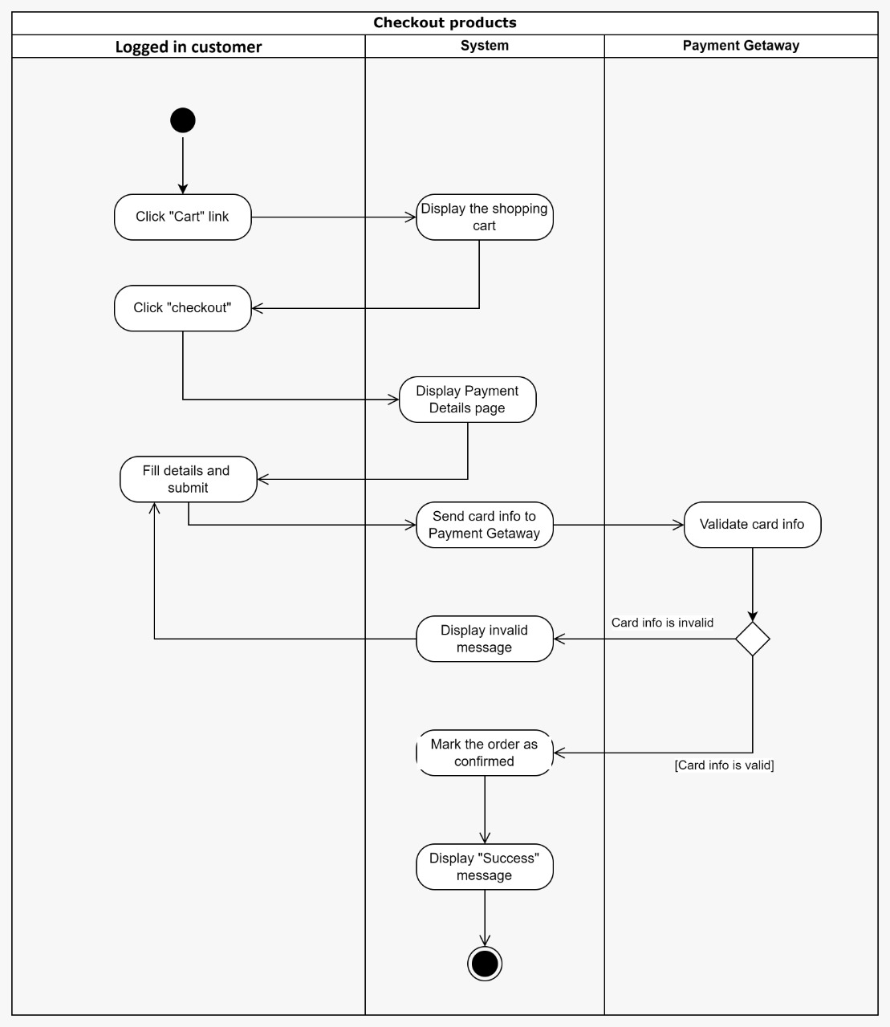

Figure 16: Checkout Products - Logged in Customer

1. Reset password

Figure 17: Forget Password – Logged in Customer

1. Graphical user interface

   Description automatically generatedView past orders

Figure 18: View Past Orders - Logged in Customer

1. View pending orders

Figure 19: View Pending Orders - Logged in Customer

1. Add to cart

Figure 20: Add to Cart - Logged in Customer

1. Graphical user interface, application

   Description automatically generatedView cart

Figure 21: View Cart - Logged in Customer

1. Manage the cart

Figure 22: Manage the Cart - Logged in Customer

1. Diagram

   Description automatically generatedMake online payment

Figure 23: Make Online Appointment - Logged in Customer

1. View payment history

Figure 24: View Payment History - Logged in Customer

1. View appointment history

Figure 25: View Appointment History - Logged in Customer

1. Manage appointments

Figure 26: Manage Appointments - Logged in Customer

1. View vehicle

Figure 27: View Vehicle - Logged in Customer

1. View the progress

Figure 28: View the Progress - Logged in Customer

1. Graphical user interface, diagram

   Description automatically generatedAdd supplier

Figure 29: Add Supplier - Stock Manager

1. Delete supplier

Figure 30: Delete Supplier - Stock Manager

1. View product reviews

Figure 31: View Product Reviews – Stock Manager

1. View orders

Figure 32: View Orders - Stock Manager

1. Update supplier

Figure 33: Update Supplier - Stock Manager

1. Add new products

Figure 34: Add New Products - Stock Manager

1. Restock products

Figure 35: Restock Products - Stock Manager

1. Graphical user interface

   Description automatically generatedRemove product

Figure 36: Remove Products - Stock Manager

1. Graphical user interface, application

   Description automatically generatedGenerate fault report

Figure 37: Generate Fault Report - Foreman

1. Text

   Description automatically generated with low confidenceCheck vehicle history

Figure 38: Check Vehicle History - Foreman

1. View jobs

Figure 39: View Jobs - Foreman

1. Manage job board

Figure 40: Manage Job Board – Foreman

1. Assign technician

Figure 41: Assign Technician - Foreman

1. Update service progress

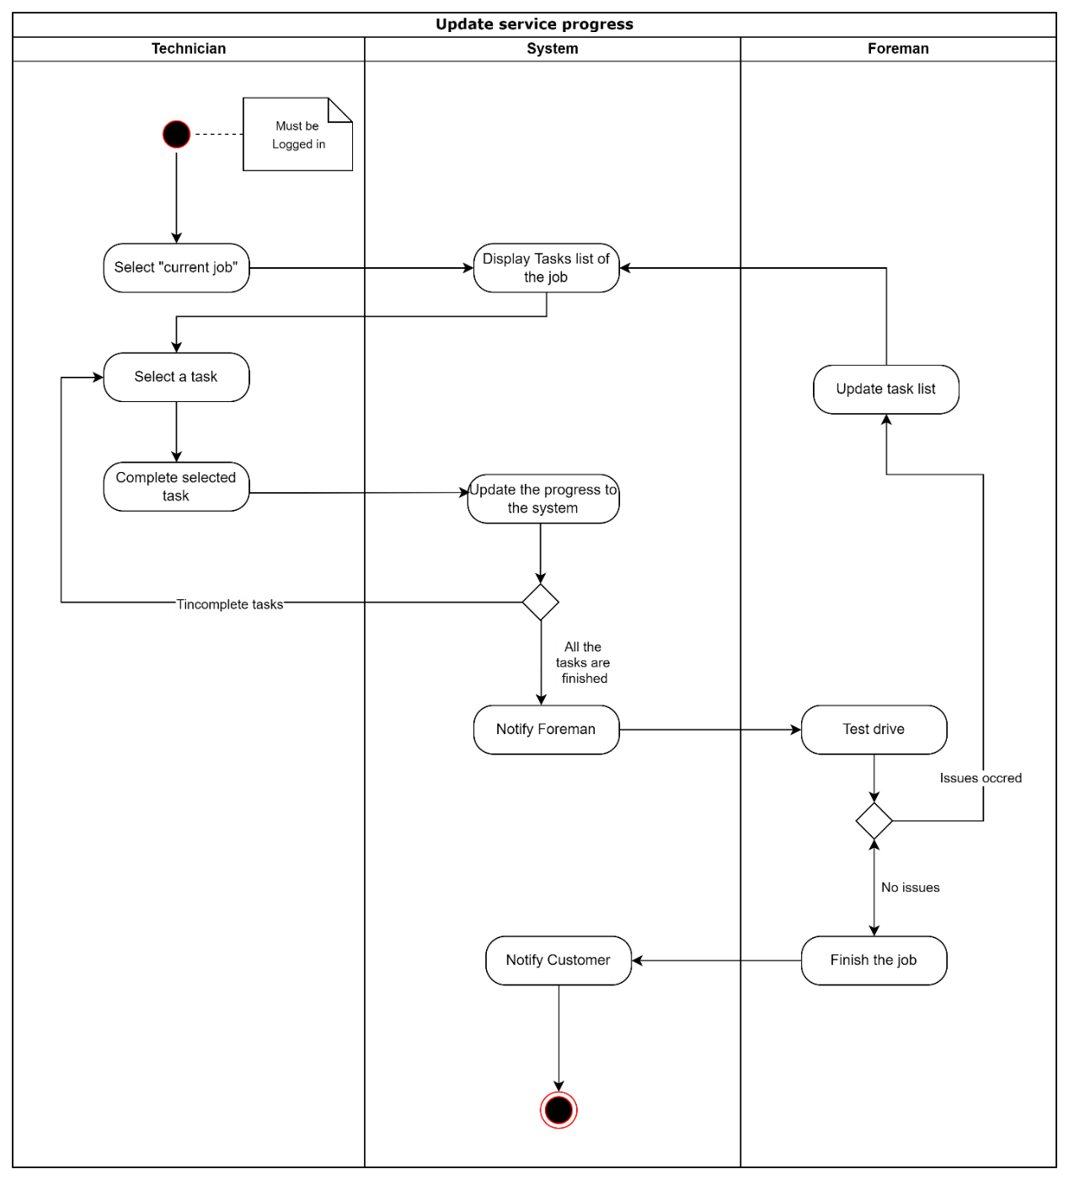

Figure 42: Update Service Progress – Technician, Foreman

1. Check admitting report

Figure 43: Check Admitting Report - Security Officer

1. Graphical user interface, application

   Description automatically generatedCheck appointment details

Figure 44: Check Appointment Details – Logged in Customer, Security Officer

1. Graphical user interface, diagram

   Description automatically generatedOpen job card

Figure 45: Open Job Card - Logged in Customer, Office Staff Member

1. Diagram

   Description automatically generatedCreate customer accounts

Figure 46: Create Customer Account - Office Staff Member

1. Graphical user interface

   Description automatically generatedMake appointments by call

Figure 47: Make Appointment by Call – Logged in Customer, Office Staff Member

1. Graphical user interface

   Description automatically generatedGenerate invoice

Figure 48: Generate Invoice - Logged in Customer, Office Staff Member

1. Diagram

   Description automatically generatedView customer details

Figure 49: View Customer Details - Office Staff Member

1. 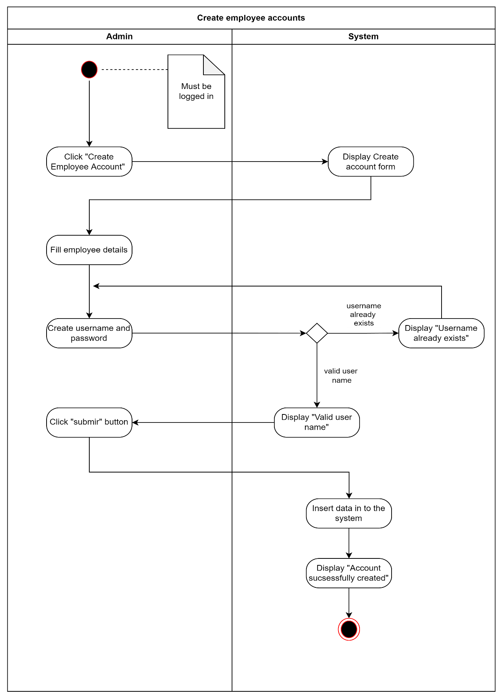Create employee accounts

Figure 50: Create employee account - Admin

1. A screenshot of a computer screen

   Description automatically generated with medium confidenceManage Employee accounts

Figure 51: Manage employee accounts - Admin

1. Graphical user interface, application, Teams

   Description automatically generatedView Analytics

Figure 52: View analytics - Admin

### Component diagram

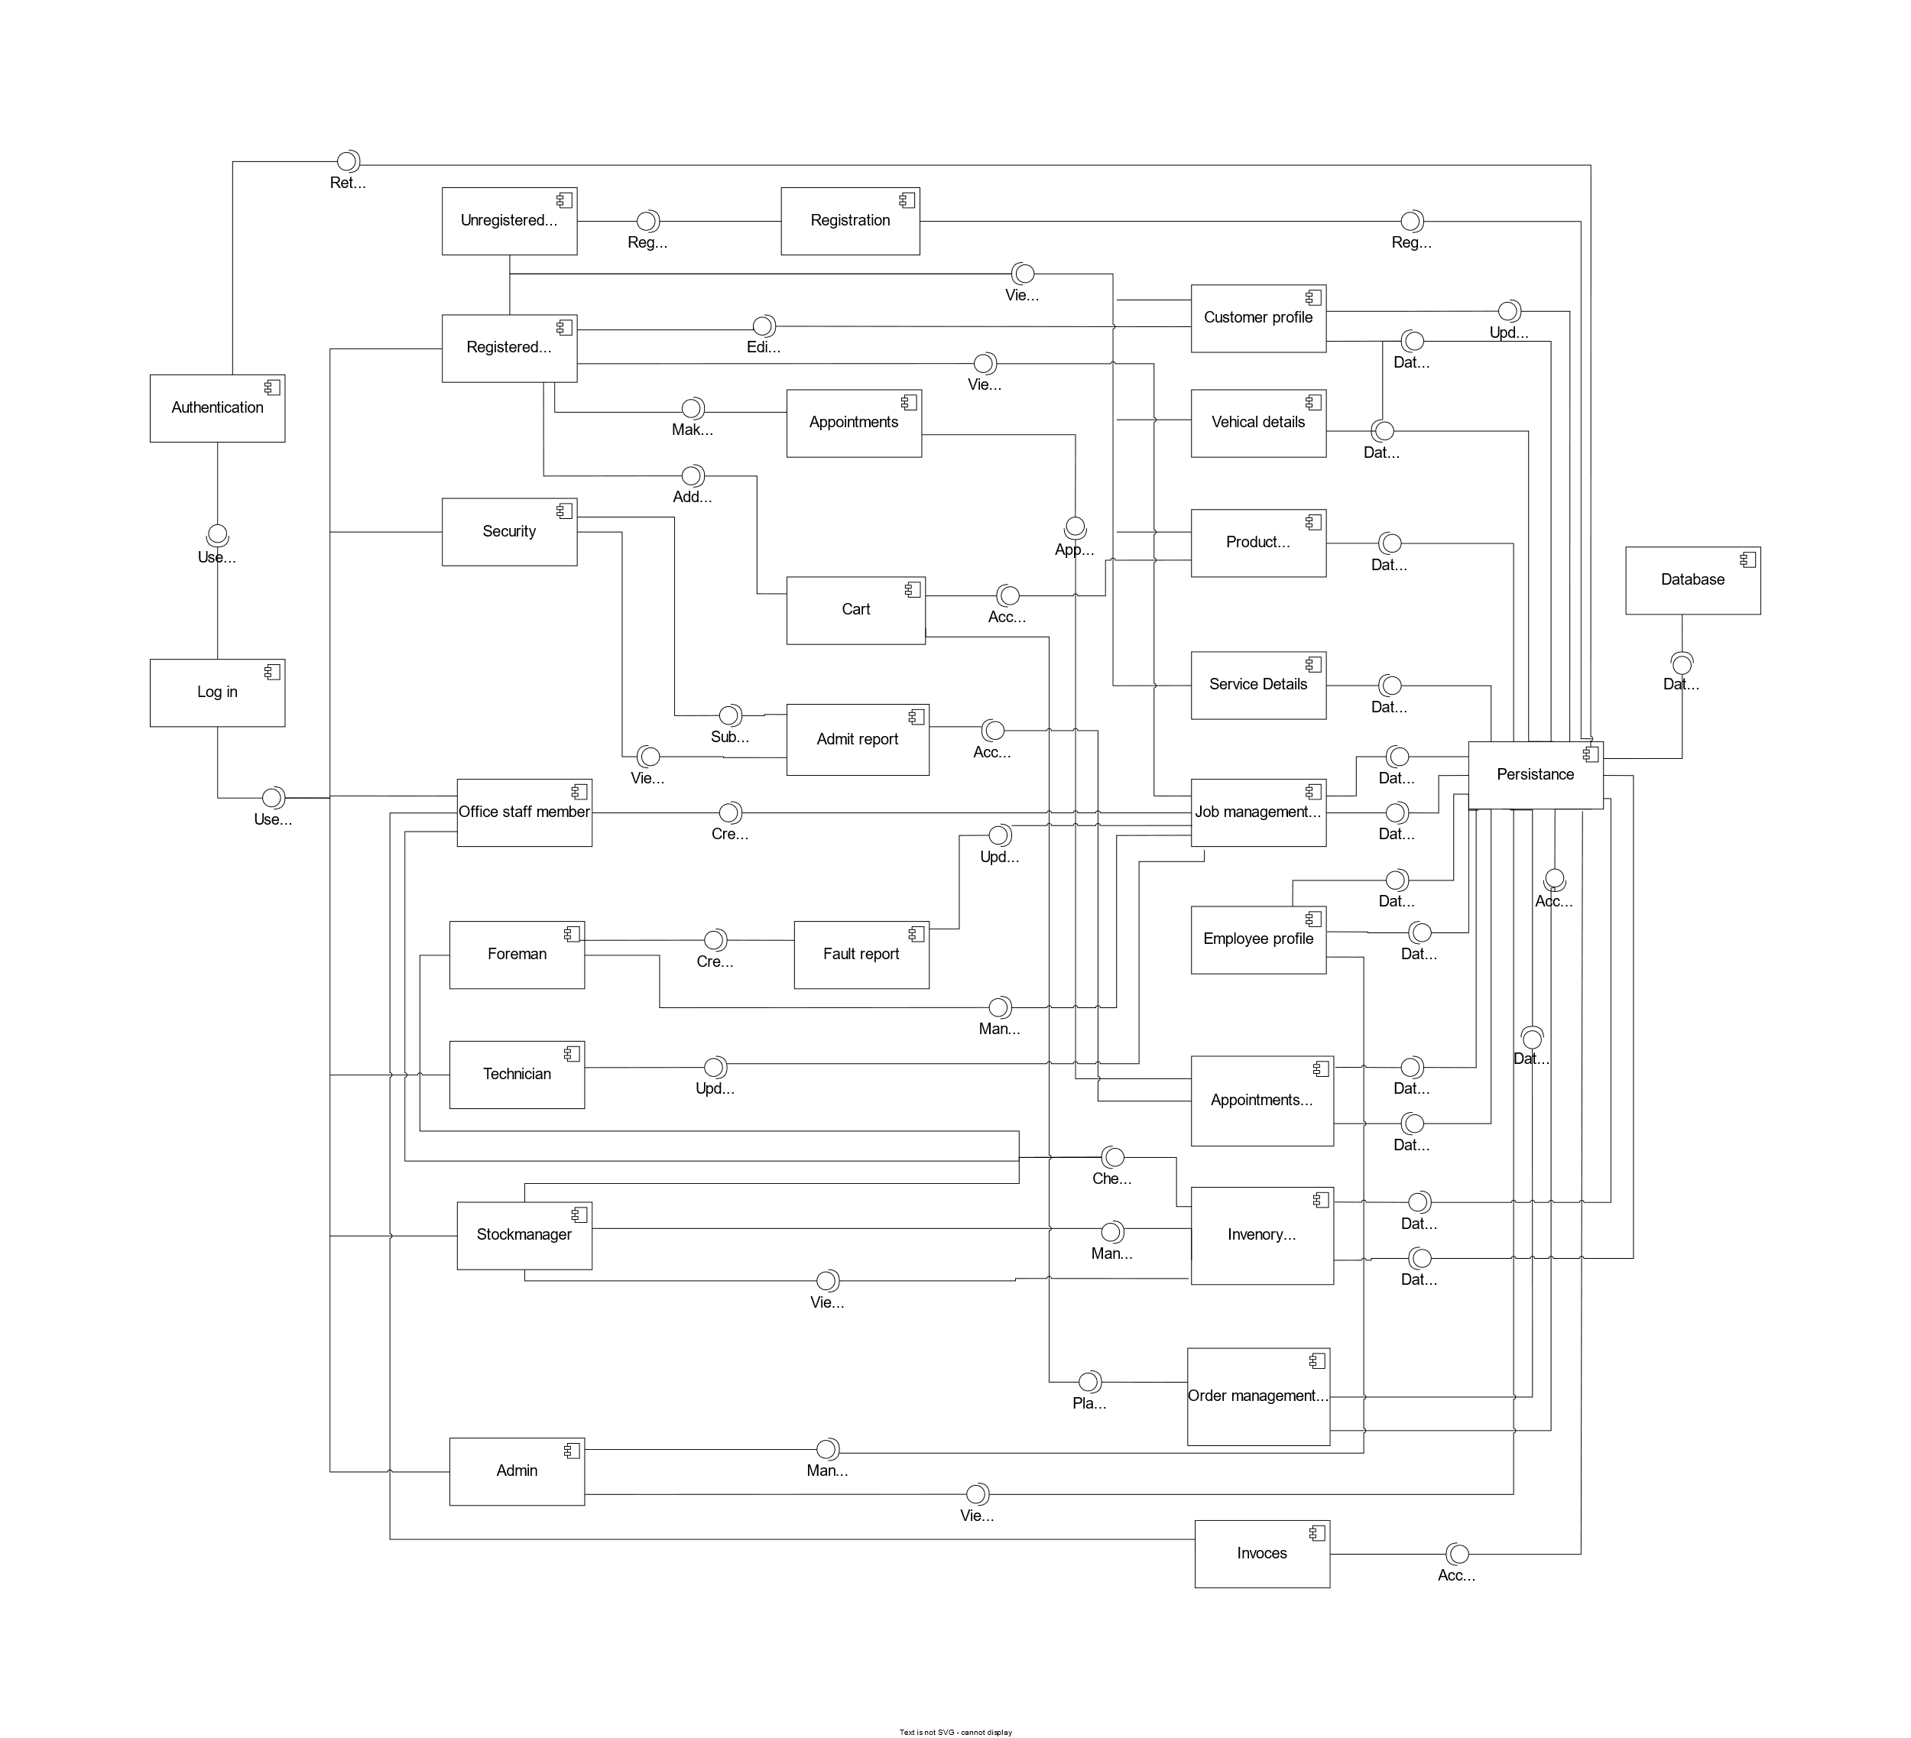

Figure 53: Component Diagram

For better view: <https://drive.google.com/file/d/19FOwrYvBAhesN83Rb089ZUoqmtICtH6U/view?usp=sharing>

## **Quality attributes**

### Availability

The system should be there and ready to carry out the functionalities when it is required. There are some techniques that are going to be used, to improve the availability of the system.

Achieved by,

* Aim is to make this website available 24/7. There will be instances that the system will be unavailable to the user due to updates and failures etc.
* The system should introduce a backup plan to protect the data. It's planned to use backup features of the hosting services for this purpose.
* Initially the system will run on a single server, but there will be a need to setup load balancing if site traffic is unmanageable with a single server.
* The plan is to make the updates at midnight since this web application is mostly used in the daytime by the users.
* In a system failure, the system will be temporarily unavailable until the recovery is done because the communication between the database and the client side is in real time. In the case of something like this, system will properly communicate the issues with the user.

### Modifiability

There can be future changes in the system according to the client requests due to business rule changes, and environmental changes such as hardware, and platform operating system. The system should be developed in a way to facilitate modifiability. There are some techniques that are going to be used, to improve the modifiability of the system.

Achieved by,

* The system should be made component by component; it is easy to add or remove any component or functionality anytime.
* Dependencies between components are minimized as much as possible.
* Applying MVC architecture.
* Setting up proper testing to make sure it's easy to modify the system

### Security

Since the system keeps track of users' private details such as email, phone numbers, NIC numbers, VIN (Vehicle Identification Number) s, etc. It's planned to secure those data as much as possible. There are some techniques that will be used to maximize security.

Achieved by,

* Each user shall have a separate user account to log in to the system.
* Users must verify their email within a given period.
* Passwords will be properly hashed and store securely.
* When the user wants to change their password, they have to prove account ownership by using verification via email address.
* Whenever the account details are modified, the user receives an email notification.
* Once the employee leaves the employment of service station, revoke their access to the system.
* Use secure database calls (sanitizing input) to prevent SQL injection attacks.

### Performance

The system should give real-time responses on appointments, and reliable information about products. All the functionalities should work smoothly, and any delay should be minimized. There are some techniques that is going to be used, to improve the performance of this system.

Achieved by,

* A simple and minimal layout for the user interfaces.
* Real-time communication between the database and the client side.
* The use of efficient database queries to minimize the insert, update, and delete time.
* Optimize the code much as possible using PHP techniques.
* Optimizing image size used on the website by using "webp" format and necessary compression.
* In dashboard, using AJAX instead of classic loading of pages to provide a smooth user experience.

### Testability

As the system is being developed, it should be tested thoroughly to minimize bugs in the code. The system should do what it is supposed to do. There are some techniques that is going to be used, to improve the testability of the system.

Achieved by,

* Using a component-based architecture to test every component individually.
* Using a set of agreed-upon coding conventions for naming and formatting the code efficiently.
* Using automated testing tools.
* We plan to test the system at every stage such as the design stage, coding stage, and deployment stage.

### Usability

The system must be user-friendly for the end users, especially those who are not highly computer and English literate. They do not need to read a huge amount of user manuals to understand the system. There are some techniques that are going to be used, so every user feels comfortable while using the system.

Achieved by,

* The web application will have a simple and highly understandable user interface to improve the interaction between the system and the end-user.
* The system is easy to use and within a few steps, the user can get the tasks done.
* Users can navigate easily in the system using understandable buttons/links.
* We provide an automatic email notification system, so the user can confirm their appointments.
* The design is responsive to various devices and different screen sizes.
* Web interfaces will have dark mode support to be accessible to people whose uncomfortable with looking at bright screens for long times.
* Scaling options for buttons and other UI components will be implemented as well.

# **Technologies to be used**

## HTML,CSS & JS Logo7.1 Front – end development

* HTML5 - Templating language used for structure of the webpage.
* CSS3 - Used for styling of the webpage.
* JavaScript - Used for client-side scripting /interactivity.

Figure 54: Front-End Development

These technologies are used because web browsers currently only support HTML, CSS, and JS. However, "Sass" will be used in development and later complied down to CSS to ease development. While most features of Sass are supported in modern CSS natively, browser versions supporting these features are fairly new hence not usable for a product that intends to support as many devices as possible.

## Back – end development

* PHP- Used to develop the backend server.

Figure 55: Back-End Development

The project uses PHP as it's easier to build a production-ready backend with PHP without using any frameworks than most other server-side technologies.

## MySQL + RedisDatabase

* MySQL for main data storage
* Redis for cache storage

Figure 56: Database

## VS CodeIDE

* Visual studio Code

Figure 57: IDE I

* PhpStorm

Figure 58: IDE II

## XamppDevelopment server

* XAMPP

Figure 59: Development Server

## GitHub LogoVersion control and collaboration

* GitHub

Figure 60: Version Control and Collaboration

## Project management tool

* Trello

Figure 61: Project Management Tool



## Diagram drawing tool

* Draw.io

Figure 62:Diagram Drawing Tool

## Storage for document

* Google drive

Figure 63:Storage Document

## Icon Description automatically generatedTeam meetings

* MS Teams

Figure 64: Team Meetings

# **Project timeline**

For this project “Waterfall model” was chose as the software process mode because there is a well-defined project scope and solid requirements. Following Gantt chart representation is a tentative timeline, and we do our best to achieve each milestone within the time frame.

Figure 65: Project Timeline

# **Declaration**

We as members of the project titled "Automobile Service and Product Management System", Certify that we will carry out this project according to the guidelines provided by the coordinators and supervisors of the course as well as we will not incorporate, without acknowledgement, any material previously submitted for a degree or diploma in any university. To the best of our knowledge and brief, the project work will not contain any material previously published or written by another person or ourselves except where due reference is made in the text of appropriate places

|  |  |  |
| --- | --- | --- |
| **Student Name** | **Index No.** | **Signature** |
| N. S. Elvitigala | 20000480 |  |
| B. A. Sathyanjana | 20001681 |  |
| E. S. D. Senewirathne | 20001738 |  |
| T. H. T. C. Gunathilaka | 20000652 |  |

Figure 66: Declaration Table

# References

|  |  |
| --- | --- |
| [1] | A. B. a. N. A. Elistina, "Consumers’ Perceptions on the Service Quality in the Motor Vehicle Repair and Service Industry," 2011. |
| [2] | F. &. .. S. Justus T, "Consumer Dissatisfaction in Service Encounter at Car Service Centers -A Scale Development Approach," 2021. |